Chapter 2: Inferences in Regression Analysis
Population model: Y_{i}=β₀+β₁X_{i}+ε_{i}
where
β₀ and β₁ are parameters
X_{i} are known constants
ε_{i} ~ independent N(0,σ²)

2.1 Inferences concerning β₁

Is X linearly related to Y?

Perform a hypothesis test to answer these questions.

Suppose β₁ = 0

Population Model: Y_{i} = β₀ + β₁X_{i} + ε_{i}

Then Y_{i} = β₀ + 0*X_{i} + ε_{i}
= β₀ + ε_{i}

Example plot:

Suppose β₀=3.

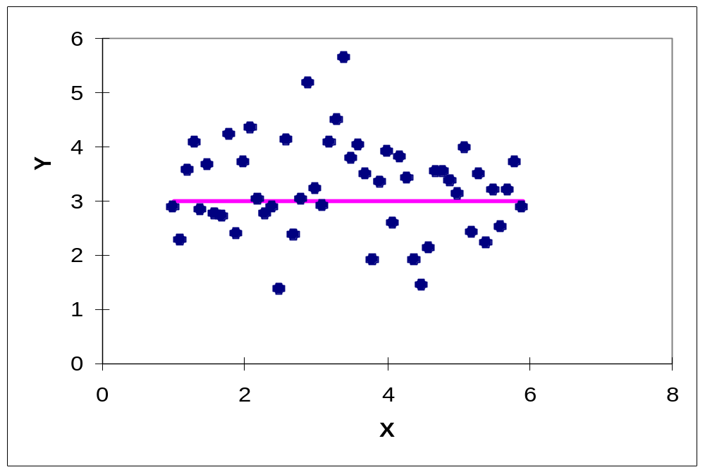

As X changes, E(Y) does not change. X is not linearly related to Y.

Use b₁ to determine if β₁ = 0 using a hypothesis test.

How? Use b₁’s sampling distribution

If we repeated the process of taking a sample from the population an infinite amount of times (calculating b₁ each time), the average of the b₁’s would be β₁, the variance of the b₁’s would be 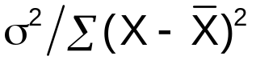, and b₁~N(β₁,).

i.e., E(b₁)=β₁ and Var(b₁)=σ²(b₁)=
(NOTE: Different notation for variance!)

Proof: We already saw that 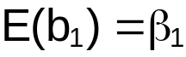 in Chapter 1. Let’s examine the variance now.

Remember that 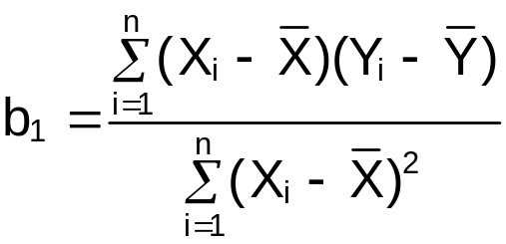. Also, note that the numerator can be simplified to be

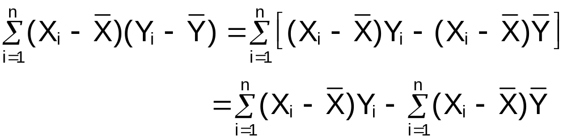
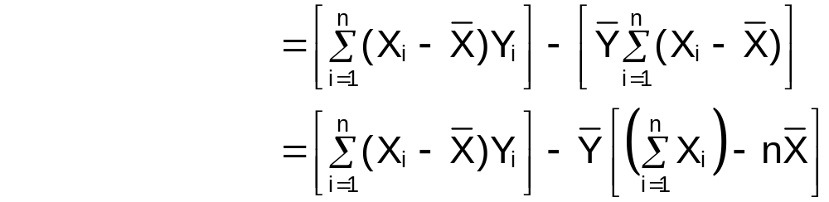
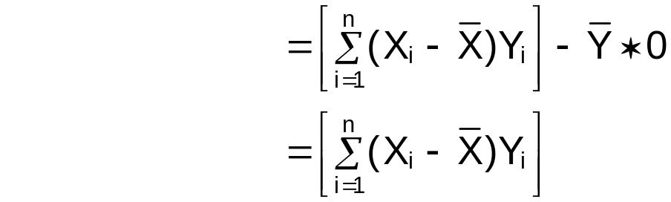

Then
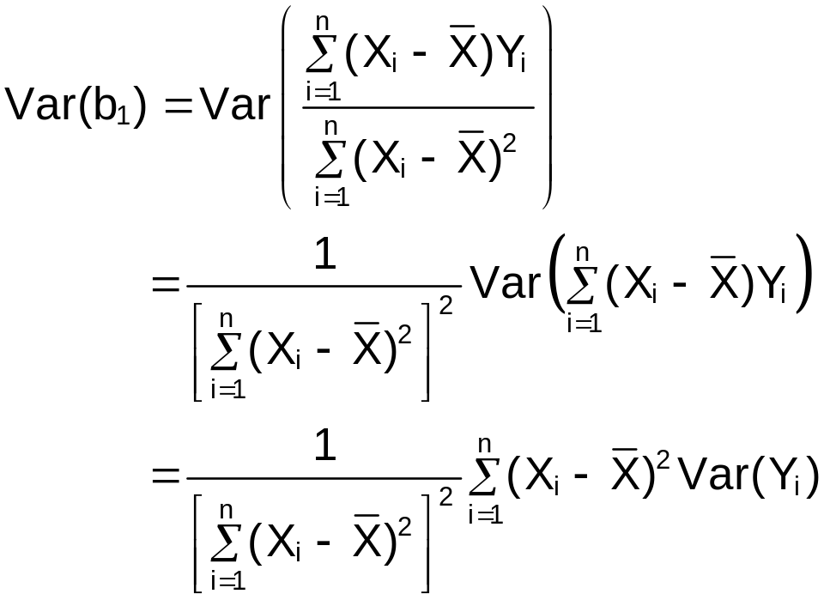
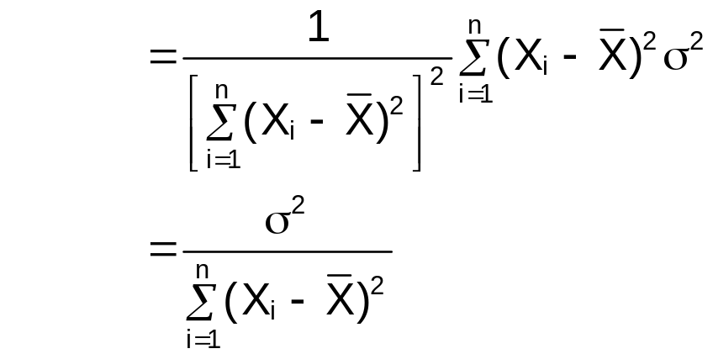

Remember that  (see p. 646 equation A.3 or Chapter 4 of my STAT 380 notes)

Notice that the variance of b₁ has a parameter in it - σ². To find the estimated variance of b₁, σ² is replaced by its estimate – MSE

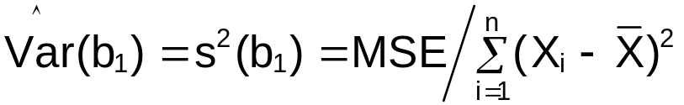

Sampling distribution of 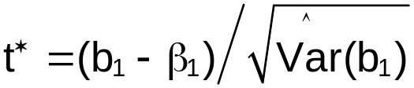

Purpose: Find a test statistic for a test of β₁=0

Note: The standardized quantity, 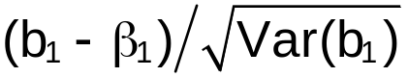, is distributed as N(0,1) random variable.

Quick Review - A standardized quantity is:
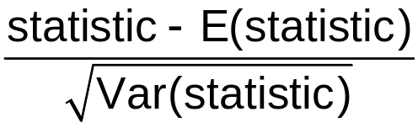

Since σ² unknown, we generally can not use this quantity for hypothesis testing.

Use the “studentized” version of the above quantity:

since this contains no unknown parameters (β₁ will be specified in the hypothesis test).

t*~t(n-2) where t(n-2) represents a random variable with a student t-distribution (or just t-distribution) with n-2 degrees of freedom.

For a proof, see p. 45 (or 11.44 of my STAT 380 Chapter 11 notes at www.chrisbilder.com/stat380/schedule.htm)

Hypothesis Test for β₁=0:
- State H₀ and H_{a}
H₀: β₁=0 (no linear relationship)
H_{a}: β₁≠0 (linear relationship)
- Test statistic:
- Critical value: ± t(1-α/2; n-2) where α is the type I error level; note that this is the 1-α/2 quantile from a t-distribution with n-2 degrees of freedom.
- Reject or don’t reject H₀
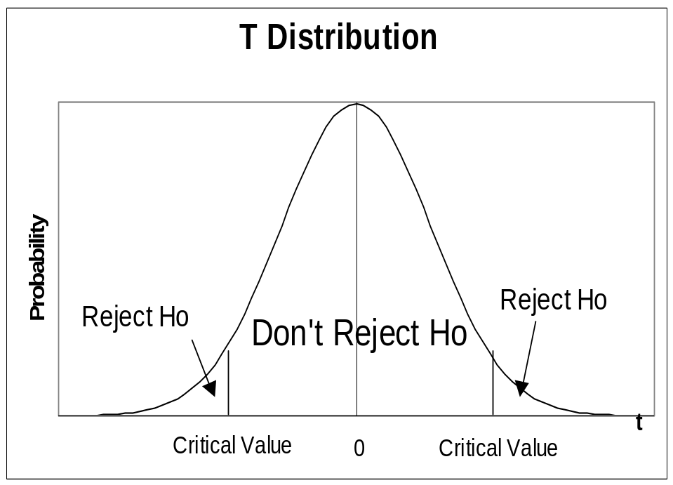

- Conclusion
Reject H₀ – X is linearly related to Y
Don’t Reject H₀ – There is not sufficient evidence to show that X is linearly related to Y

where ____ means to put in what X and Y are in the problem

Using a p-value:
1) Same
2) State p-value: p-value = 2*P( t(n-2) > |t*|)
where t(n-2) denotes a t random variable with n-2 degress of freedom

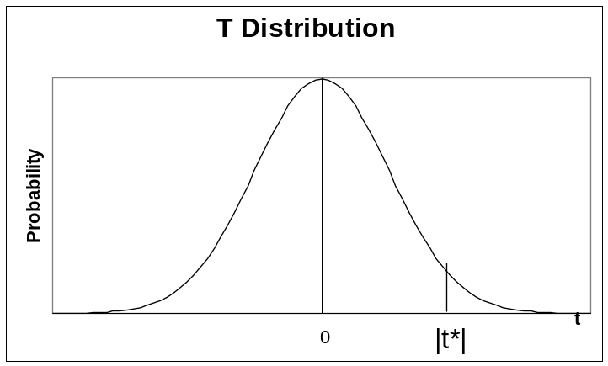

Note: The p-value gives the probability of finding a value of |t*| at least this great assuming the null hypothesis is true.

3) State α
4) Reject H₀ if p-value ≤ α
Don’t reject H₀ if p-value > α
5) Same

How can you find p-values and critical values in R for the t-distribution?

In the summary() output for an object resulting from using lm(), the p-value for a test of H₀: β₁=0 vs. H_{a}: β₁≠0 will be given. The more general way to find it is using the pt() function which finds the probability of random variable t(n-2) is less than a particular value. For example, if the test statistic was 1.96 with 10 degrees of freedom, we obtain P(t(n-2) < 1.96),

> pt(q = 1.96, df = 10)
[1] 0.9607819

Since the p-value is 2∗P( t(n-2) > |t*|), we can change this to

> 2*(1-pt(q = abs(1.96), df = 10))
[1] 0.07843624

To find a critical value, use the qt() function,

> qt(p = 0.95, df = 10)
[1] 1.812461

Thus, P( t(n-2) < 1.81) = 0.95; i.e., 1.81 is the 0.95 quantile from a t-distribution with 10 degrees of freedom.

(1-α)100% confidence interval (C.I.) for β₁:

The “usual” type of t-distribution based confidence interval is: Estimator ± t(1-α/2, df)*(S.E. of estimator)

where df=degrees of freedom and S.E. is standard error

For β₁: 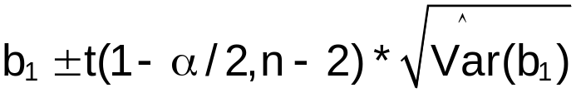

This can be rewritten as:
See p. 2.20 for a review of how knowing the distribution of t* can be used to find a C.I.

Example: Sales and advertising

Is advertising linearly related to sales? Use α=0.05
1) H₀: β₁=0
H_{a}: β₁≠0
2) = 0.70/0.1915 = 3.6556

X | Y | (X-)²
1 | 1 | 4
2 | 1 | 1
3 | 2 | 0
4 | 2 | 1
5 | 4 | 4
Σ |  | 10
Note:
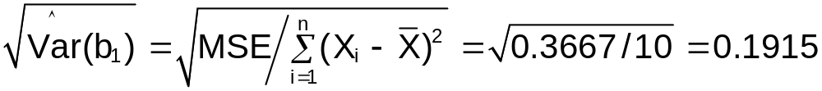

- ± t(1-0.05/2; 5-2) =± t(0.975;3)= ±3.182

> qt(p = 1-0.05/2, df = 3)
[1] 3.182446

- Since 3.6556 > 3.182 reject H₀.
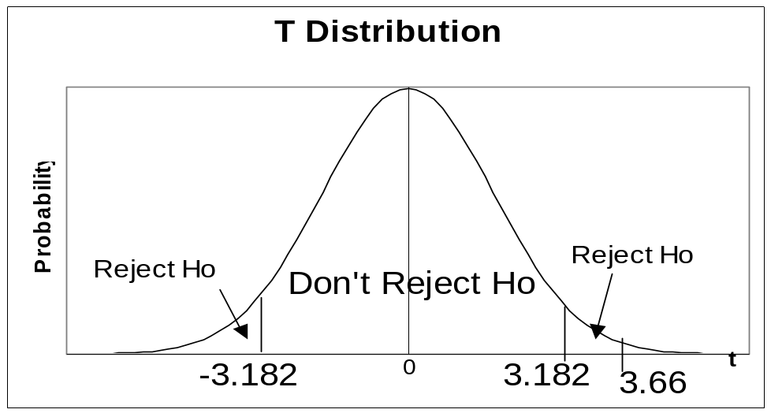
5) Advertising is linearly related to sales.

See t-dist_program.R for an R program that shows how to draw a plot similar to the one above.

Example: HS and College GPA (HS_college_GPA_ch2.R)

Suppose α = 0.01 for the hypothesis test.

> #Fit the simple linear regression model and save the
results in mod.fit
> mod.fit<-lm(formula = College.GPA ~ HS.GPA, data = gpa)
> summary(mod.fit)

Call:
lm(formula = College.GPA ~ HS.GPA, data = gpa)

Residuals:
Min 1Q Median 3Q Max
-0.42294 -0.25711 -0.04094 0.27536 0.40334

Coefficients:
Estimate Std. Error t value Pr(>|t|)
(Intercept) 0.70758 0.19941 3.548 0.00230 **
HS.GPA 0.69966 0.07319 9.559 1.78e-08 ***
---
Signif. codes: 0 `***' 0.001 `**' 0.01 `*' 0.05 `.' 0.1 ` ' 1
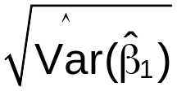 t* p-value
Residual standard error: 0.297 on 18 degrees of freedom
Multiple R-Squared: 0.8354, Adjusted R-squared: 0.8263
F-statistic: 91.38 on 1 and 18 DF, p-value: 1.779e-08

1) H₀: β₁=0
H_{a}: β₁≠0
2) p-value = 1.78∗10⁻⁸ = 0.000000178
3) α=0.01
4) Since 0.000000178 < 0.01 reject H₀
5) HS GPA is linearly related to college GPA

Thus, HS GPA can be used to predict college GPA.

P-value interpretation:
If β₁ is really 0 in the population, then a test statistic value, t*, at least this large in absolute value (9.559) would occur less than 178 times if the hypothesis test process (take a new sample and perform a new hypothesis test) is repeated 1 billion times. This is about 2 times in 10 million!

In other words, this is very unlikely to occur if β₁=0. Thus, β₁ is most likely not 0 and H₀ is rejected.

Examine the plot below produced in Chapter 1 and relate the hypothesis test result to it.
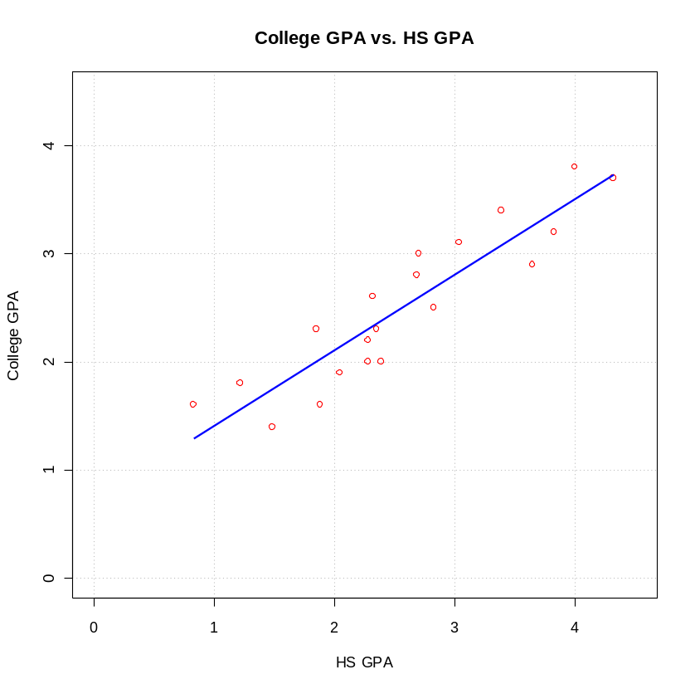

Example: College pizza consumption and College GPA (college_GPA_pizza.R)

Suppose we also want to know if there is a linear relationship between the number of times students eat pizza during their freshman year of college and their college GPA. The same 20 students are in this sample.
Suppose X = number of times ate pizza in the last semester

> #Read in the data
> gpa2<-read.table(file = "C:\\chris\\UNL\\STAT870\\Chapter2\\data\\College_GPA_pizza.txt", header=TRUE, sep = "")
> head(gpa2)
pizza College.GPA
1 2 3.1
2 9 2.3
3 3 3.0
4 5 1.9
5 3 2.5
6 1 3.7

> #Fit the simple linear regression model and save the
results in mod.fit
> mod.fit<-lm(formula = College.GPA ~ pizza, data = gpa2)

> #Summarize the information stored in mod.fit
> summary(mod.fit)

Call:
lm(formula = College.GPA ~ pizza, data = gpa2)

Residuals:
Min 1Q Median 3Q Max
-1.11403 -0.52586 -0.08769 0.53543 1.29349

Coefficients:
Estimate Std. Error t value Pr(>|t|)
(Intercept) 2.468866 0.289987 8.514 9.99e-08 ***
pizza 0.007528 0.049879 0.151 0.882
---
Signif. codes: 0 '***' 0.001 '**' 0.01 '*' 0.05 '.' 0.1 ' ' 1

Residual standard error: 0.7317 on 18 degrees of freedom
Multiple R-Squared: 0.001264, Adjusted R-squared: -0.05422
F-statistic: 0.02278 on 1 and 18 DF, p-value: 0.8817

> #Scatter plot with sample model plotted
> plot(x = gpa2$pizza, y = gpa2$College.GPA, xlab = "Times
ate pizza", ylab = "College GPA", main = "College
GPA vs. Pizza consumption",
ylim = c(0,4), col = "black", pch = 1, lwd = 2,
panel.first = grid(col = "gray", lty = "dotted"))
> curve(expr = mod.fit$coefficients[1] +
mod.fit$coefficients[2]*x, col = "red", lty =
"solid", lwd = 2, add = TRUE, xlim =
c(min(gpa2$pizza), max(gpa2$pizza)))
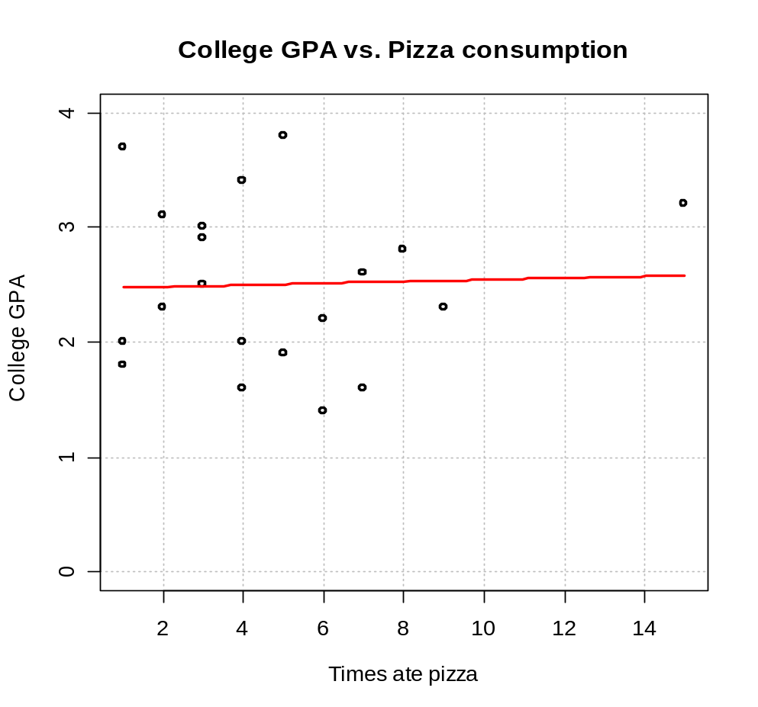
Use α=0.01 for the hypothesis test.
1) H₀: β₁=0
H_{a}: β₁≠0
2) p-value = 0.882
3) α=0.01
4) Since 0.882 > 0.01 don’t reject H₀
5) There is not sufficient evidence to show that the number of times students eat pizza during their freshman year is linearly related to college GPA.

Examine  here and compare it to the previous model using HS GPA.

One-sided tests for β₁:

Example: Is there positive slope?
Test H₀:β₁0 vs. H_{a}:β₁>0

Reject H₀ if t*>t(1-α,n-2)

Example: Is there negative slope?
Test H₀:β₁0 vs. H_{a}:β₁<0

Reject H₀ if t*<-t(1-α,n-2)

Hypothesis test for β₁=β₁₀ or β₁≥β₁₀ or β₁≤β₁₀:

β₁₀ is some constant not equal to 0

Example: Testing “beta coefficients” in investing

Let X = daily rate of return for a stock of interest and Y = daily rate of return for an “average stock” (assume it is measured by the S&P 500 Index)

H₀: β₁1 vs. H_{a}: β₁>1

A “beta coefficient” is a measure of a stock’s relative risk to that of the “average” stock (Bringham and Houston, 1998)

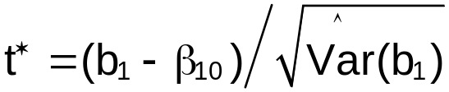

2.2 Inferences concerning β₀

Note that β₀ is often not meaningful in a particular problem. For example, suppose 10<X<50 in a population. Then β₀, the y-intercept (at X=0, the value of Y) does not have a meaningful interpretation.

Use b₀ to determine if β₀ = 0 using a hypothesis test.

How? Use b₀’s sampling distribution
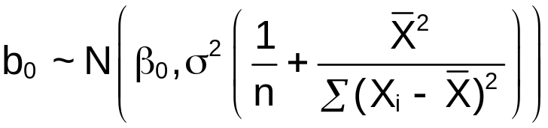

Test statistic: 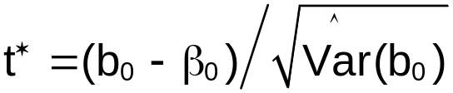

2.3 Some considerations on making inferences concerning β₀ and β₁

The sampling distributions for b₀ and b₁ hold true ONLY if ε_{i} ~ ind. N(0,σ²) assumption holds; however, if the normality assumption does not hold, these sampling distributions are usually still good approximations.

2.4 Interval estimation of E(Y_{h})

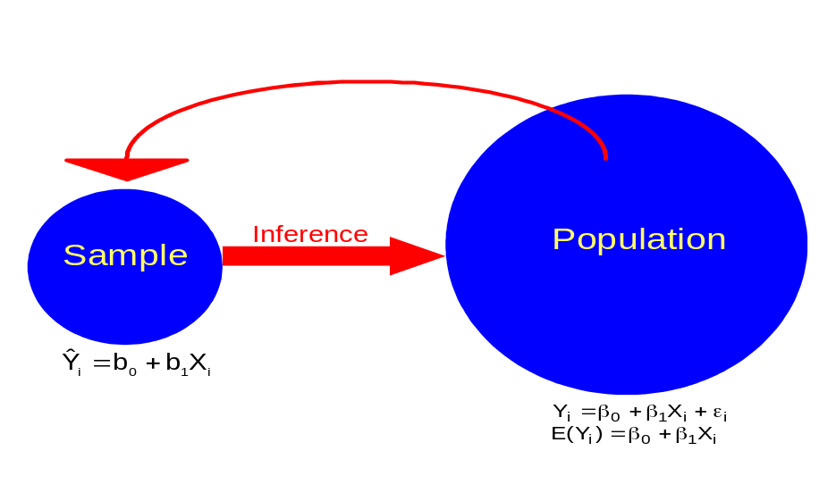

Estimate the mean value of Y_{h}, E(Y_{h}), at a specific X_{h} value

X_{h} may or may not be value in the sample

The subscript h is just to help distinguish this from the sample values that have a subscript i=1,…,n.

The estimated value of E(Y_{h}) is 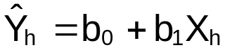

To make the inference from the sample to the population, we must use the sampling distribution of  to help construct a confidence interval for E(Y_{h}).

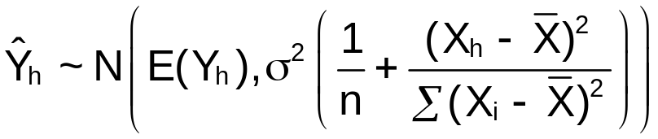
this follows from Y_{i}~N(β₀+β₁X_{i},σ²) and can be written as a linear combination of Y_{i}.

Using MSE to estimate σ² produces
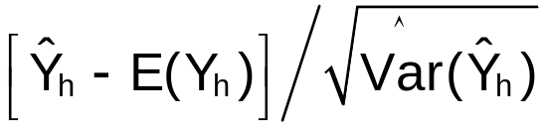 ~ t(n-2)

where 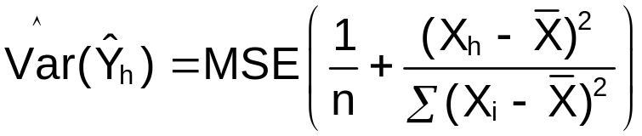

(1-α)100% C.I. for E(Y_{h}):
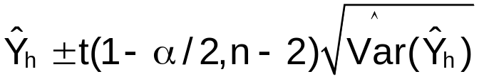

Note that the distance of X_{h} from  affects the size of 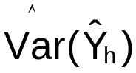!

Questions:
- Which results in a larger variance, X_{h} being close to or X_{h} being far from ?
- Which results in a wider confidence interval, X_{h} being close to or X_{h} being far from ?
- Why is this important to know???

How does knowing ~ t(n-2) help derive the C.I. formula?
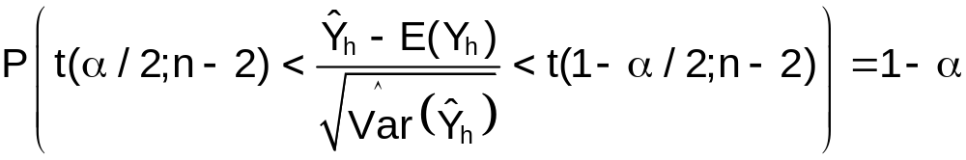

When the interval is actually calculated, random variables are replaced by their observed values. Thus, the “probability” that one C.I. contains E(Y_{h}) is unknown. Instead, if the sampling process was repeated 1,000 times and the C.I. (along with the b₀, b₁, …) was calculated each time, about 1,000∗(1-α) of intervals would contain the one value of E(Y_{h}).

2.5 Prediction of a new observation

Instead of estimating E(Y_{h}), we want to predict the random variable, Y_{h}, with an interval. This interval is called a “prediction interval” to help differentiate it from the “confidence interval” in the previous section.

This is often thought of as estimating a “new” draw from the population. Thus, KNN uses the notation of Y_{h(new)} to denote this new value.

The difference is between estimating the mean of all Y_{h}’s for a particular X_{h} (denoted by E(Y_{h})) versus predicting an actual random variable, Y_{h}.
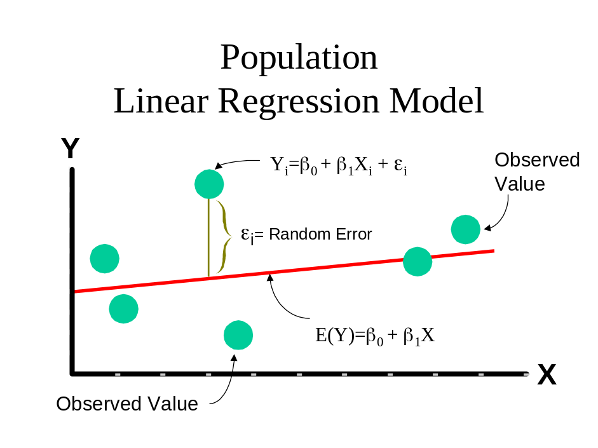
Note that E(Y_{h}) = β₀+β₁X_{h} and Y_{h} = β₀+β₁X_{h}+ε_{h}.

One can show that 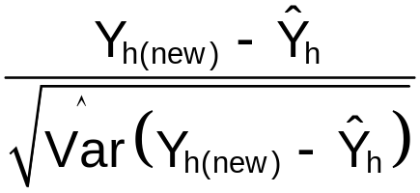 has a t-distribution with n-2 degrees of freedom. Using this information, a “prediction interval” for Y_{h(new)} can be derived the usual way as for “confidence intervals”, but with Y_{h(new)} in the middle. Specifically,

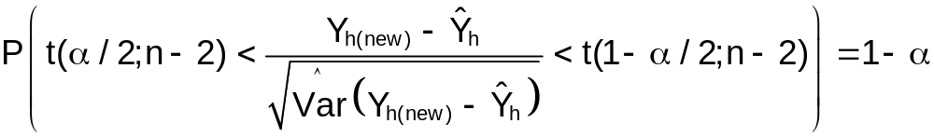
leads to
In the estimation of Y_{h}, there is more variability since ε_{h}~N(0,σ²) (i.e., we are now estimating a random variable instead of a parameter). Therefore, 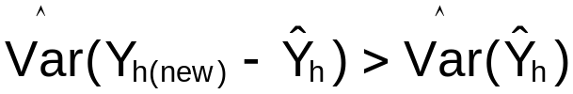.

Y_{h(new)} is best estimated by .

The variance in the prediction error is
Var(Y_{h(new)}-) = Var(Y_{h(new)}) + Var() by the independence of the original sample and the new observation (p.645 equation A.29b). Then
Var(Y_{h(new)} -)= σ²+ 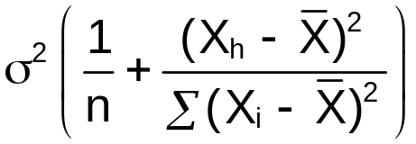
= 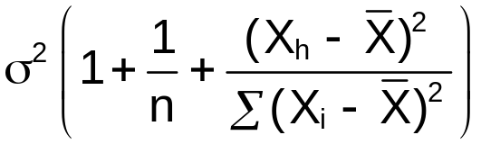

Note that Var() came from p. 2.19 and Var(Y_{h(new)}) = Var(β₀+β₁X_{h(new)}+ε_{h(new)}) = Var(ε_{h(new)}) = σ².

(1-α)100% prediction interval (P.I.) for Y_{h(new)}:
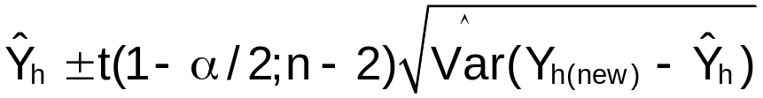

where 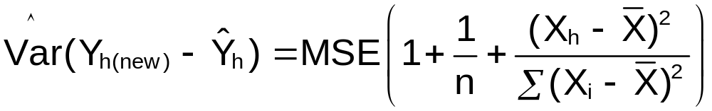

Note: The above is for predicting a single new observation. For predicting the mean of multiple new observations (say, 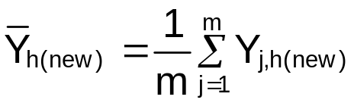), the (1-α)100% prediction interval is:

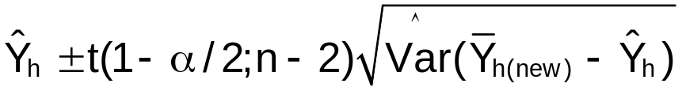

where

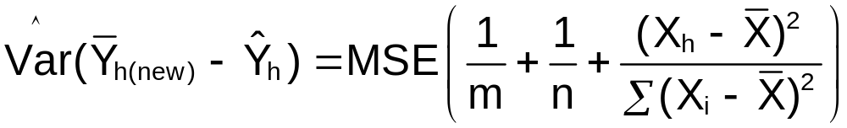

and m=# of new observations. Look what happens to the above variance when m gets VERY big (m→∞).

Example: HS and College GPA (HS_college_GPA_ch2.R)

- Estimate the average college GPA for students with a HS GPA of 1.88 (Find a 95% C.I. for the mean college GPA). Note that 1.88 is X_{h=1}.
- Predict the college GPA for a student with a HS GPA of 1.88 (Find a 95% P.I. for a student’s college GPA)

Some calculations:
> #Read in the data
> gpa<-read.table(file = "C:\\chris\\UNL\\STAT870\\Chapter1\\gpa.txt", header=TRUE, sep = "")
> head(gpa)
HS.GPA College.GPA
1 3.04 3.1
2 2.35 2.3
3 2.70 3.0
4 2.05 1.9
5 2.83 2.5
6 4.32 3.7

> #Fit the simple linear regression model and save the
results in mod.fit
> mod.fit<-lm(formula = College.GPA ~ HS.GPA, data = gpa)
> sum.fit<-summary(mod.fit)
> sum.fit

Call:
lm(formula = College.GPA ~ HS.GPA, data = gpa)

Residuals:
Min 1Q Median 3Q Max
-0.42294 -0.25711 -0.04094 0.27536 0.40334

Coefficients:
Estimate Std. Error t value Pr(>|t|)
(Intercept) 0.70758 0.19941 3.548 0.00230 **
HS.GPA 0.69966 0.07319 9.559 1.78e-08 ***
---
Signif. codes: 0 '***' 0.001 '**' 0.01 '*' 0.05 '.' 0.1 ' ' 1

Residual standard error: 0.297 on 18 degrees of freedom
Multiple R-Squared: 0.8354, Adjusted R-squared: 0.8263
F-statistic: 91.38 on 1 and 18 DF, p-value: 1.779e-08

> MSE<-sum.fit$sigma^2
> names(sum.fit)
[1] "call" "terms" "residuals" "coefficients" "aliased"
[6] "sigma" "df" "r.squared" "adj.r.squared" "fstatistic"
[11] "cov.unscaled"

> #"By hand" calculations - normally, you would not want to
do it in R this way
> alpha<-0.05
> n<-nrow(gpa)
> quant.t<-qt(p = 1-alpha/2, df = n-2)
> X.h<-1.88
> Y.hat.h<-as.numeric(mod.fit$coefficients[1] +
mod.fit$coefficients[2]*X.h)
> #as.numeric just removes an unneeded name (try without it
to see what happens)

> ssx<-var(gpa$HS.GPA)*(n-1) #SUM( (X_i - X_bar)^2 )
> X.bar<-mean(gpa$HS.GPA)

> low.ci<-round(Y.hat.h - quant.t*sqrt(MSE * (1/n + (X.h –
X.bar)^2 / ssx)),3)
> up.ci<-round(Y.hat.h + quant.t*sqrt(MSE * (1/n + (X.h –
X.bar)^2 / ssx)),3)
> low.pi<-round(Y.hat.h - quant.t*sqrt(MSE * (1 + 1/n +
(X.h - X.bar)^2 / ssx)),3)
> up.pi<-round(Y.hat.h + quant.t*sqrt(MSE * (1 + 1/n + (X.h
- X.bar)^2 / ssx)),3)

> data.frame(alpha, n, quant.t, X.h, Y.hat.h, ssx,
X.bar, MSE, low.ci, up.ci, low.pi, up.pi)
alpha n quant.t X.h Y.hat.h ssx X.bar MSE
1 0.05 20 2.100922 1.88 2.022935 16.46818 2.569 0.08822035

low.ci up.ci low.pi up.pi
1.848 2.198 1.375 2.671

a)
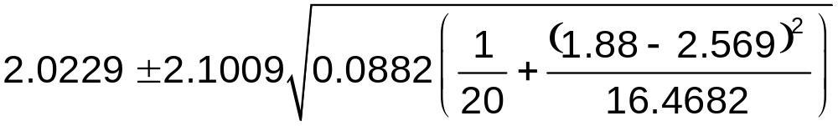
1.848 ≤ E(Y_{h}) ≤ 2.198

Interpretation: With 95% confidence, the average college GPA is between 1.848 and 2.198 for a HS GPA of 1.88.

b)
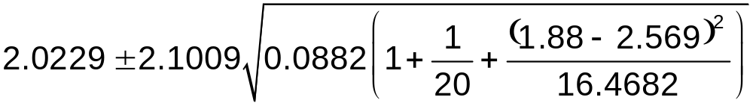
1.375 ≤ Y_{h(new)} ≤ 2.671

Interpretation: With 95% confidence, a student with a 1.88 HS GPA should expect between a 1.375 and 2.671 college GPA

Confidence interval and prediction interval bands
95% C.I. and P.I. intervals drawn on a scatter plot (with the estimated regression line) showing the intervals for all possible X values in the data set.

Code:

#Simple scatter plot
plot(x = gpa$HS.GPA, y = gpa$College.GPA, xlab = "HS GPA", ylab =
"College GPA", main = "College GPA vs. HS GPA",
xlim = c(0,4.5), ylim = c(0,4.5), col = "black", pch = 1, cex =
1.0, panel.first = grid(col = "gray", lty = "dotted"))
curve(expr = mod.fit$coefficients[1] + mod.fit$coefficients[2]*x,
col = "red", lty = "solid", lwd = 1, add = TRUE, xlim =
c(min(gpa$HS.GPA), max(gpa$HS.GPA)))
curve(expr = mod.fit$coefficients[1] + mod.fit$coefficients[2]*x –
quant.t*sqrt(MSE * (1/n + (x - X.bar)^2 / ssx)),
col = "darkgreen", lty = "dashed", lwd = 1, add = TRUE, xlim =
c(min(gpa$HS.GPA), max(gpa$HS.GPA)))
curve(expr = mod.fit$coefficients[1] + mod.fit$coefficients[2]*x +
quant.t*sqrt(MSE * (1/n + (x - X.bar)^2 / ssx)),
col = "darkgreen", lty = "dashed", lwd = 1, add = TRUE, xlim =
c(min(gpa$HS.GPA), max(gpa$HS.GPA)))
curve(expr = mod.fit$coefficients[1] + mod.fit$coefficients[2]*x –
quant.t*sqrt(MSE * (1 + 1/n + (x - X.bar)^2 / ssx)),
col = "blue", lty = "dashed", lwd = 1, add = TRUE, xlim =
c(min(gpa$HS.GPA), max(gpa$HS.GPA)))
curve(expr = mod.fit$coefficients[1] + mod.fit$coefficients[2]*x +
quant.t*sqrt(MSE * (1 + 1/n + (x - X.bar)^2 / ssx)),
col = "blue", lty = "dashed", lwd = 1, add = TRUE, xlim =
c(min(gpa$HS.GPA), max(gpa$HS.GPA)))
legend(locator(1), legend = c("Sample model", "95% C.I.", "95%
P.I."), col = c("red", "darkgreen", "blue"),
lty = c("solid", "dashed", "dashed"), bty = "n", cex = 0.75)
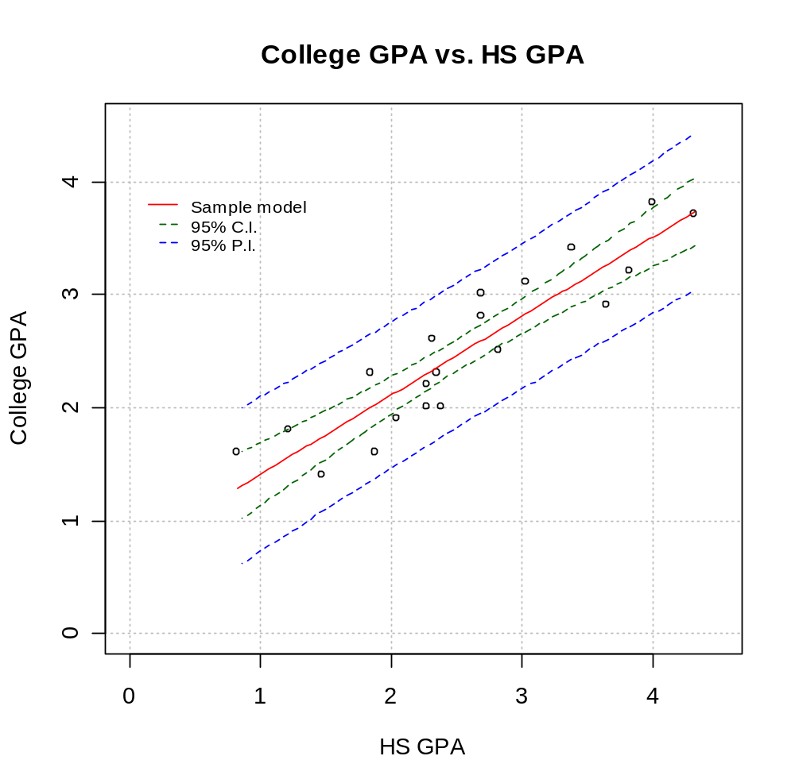
Note:
- P.I. bands are outside of the C.I. bands.
- The bands are tighter when they are closer to the mean HS GPA.
- If given this plot, one can get the C.I. or P.I. for a X_{h} (see upcoming plot).
- Remember to use a C.I. and P.I. only in the range of min(X)X_{h}max(X).

Easier ways to do the above:

> more.gpa<-data.frame(HS.GPA = c(1.88, 2, 3, 4))
> predict(object = mod.fit, newdata = more.gpa, se.fit =
TRUE, interval = "confidence", level = 0.95)
$fit
fit lwr upr
1 2.022935 1.847737 2.198134
2 2.106894 1.942197 2.271591
3 2.806553 2.652079 2.961026
4 3.506211 3.245655 3.766767

$se.fit
1 2 3 4
0.08339129 0.07839267 0.07352648 0.12401980

$df
[1] 18

$residual.scale
[1] 0.2970191

> predict(object = mod.fit, newdata = more.gpa, se.fit =
TRUE, interval = “prediction”, level = 0.95)
$fit
fit lwr upr
1 2.022935 1.374793 2.671077
2 2.106894 1.4615119 2.752277
3 2.806553 2.1637033 3.449402
4 3.506211 2.8299842 4.182438

$se.fit
1 2 3 4
0.08339129 0.07839267 0.07352648 0.12401980

$df
[1] 18

$residual.scale
[1] 0.2970191

Notes:
- The results from predict() are in a list format and parts of them (if saved into an object) can be accessed similar to what we did for results from lm().
- Question: Suppose I used save.it<-predict(object = mod.fit, …). How would I access the confidence or prediction intervals from the save.it object?
- The se.fit = TRUE option only gives 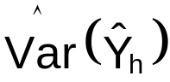, not 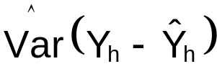 even if P.I.s are requested.

Easier code for the C.I. and P.I. bands plot (this shows some good examples of using the curve() function):

#Open a new graphics window
win.graph(width = 6, height = 6, pointsize = 12)
par(pty = "s") #Make sure plot is square, pty = “m” is
default
par(xaxs = "i", yaxs = "i") #Use "r" to set it back

#C.I. and P.I. bands plot
plot(x = gpa$HS.GPA, y = gpa$College.GPA, xlab = "HS GPA",
ylab = "College GPA", main = "College GPA vs. HS GPA",
xlim = c(0,4.5), ylim = c(0,4.5), col = "black", pch =
1, cex = 1.0, panel.first = grid(col = "gray", lty =
"dotted"))
curve(expr = predict(object = mod.fit, newdata =
data.frame(HS.GPA = x)), col = "red", lty = "solid", lwd
= 1, add = TRUE, xlim = c(min(gpa$HS.GPA),
max(gpa$HS.GPA)))
curve(expr = predict(object = mod.fit, newdata =
data.frame(HS.GPA = x), interval = "confidence", level =
0.95)[,2], col = "darkgreen", lty = "dashed", lwd = 1,
add = TRUE, xlim = c(min(gpa$HS.GPA),
max(gpa$HS.GPA)))
curve(expr = predict(object = mod.fit, newdata =
data.frame(HS.GPA = x), interval = "confidence", level =
0.95)[,3], col = "darkgreen", lty = "dashed", lwd = 1,
add = TRUE, xlim = c(min(gpa$HS.GPA),
max(gpa$HS.GPA)))
curve(expr = predict(object = mod.fit, newdata =
data.frame(HS.GPA = x), interval = "prediction", level =
0.95)[,2], col = "blue", lty = "dashed", lwd = 1, add =
TRUE, xlim = c(min(gpa$HS.GPA),
max(gpa$HS.GPA)))
curve(expr = predict(object = mod.fit, newdata =
data.frame(HS.GPA = x), interval = "prediction", level
= 0.95)[,3], col = "blue", lty = "dashed", lwd = 1,
add = TRUE, xlim = c(min(gpa$HS.GPA),
max(gpa$HS.GPA)))
legend(locator(1), legend = c("Sample model", "95% C.I.",
"95% P.I."), col = c("red", "darkgreen", "blue"),
lty = c("solid", "dashed", "dashed"), bty = "n", cex
= 0.75)

Model code and output showing the lower bound of the P.I.:

> #Graphical example (using the plot above) showing the
lower bound of the P.I.
> save.pred<-predict(object = mod.fit, newdata =
data.frame(HS.GPA = X.h), interval =
"prediction", level = 0.95)
> save.pred
fit lwr upr
[1,] 2.022935 1.374793 2.671077
> segments(x0 = X.h, y0 = 0, x1 = X.h, y1 =
save.pred[1,2], lty = 2, col = "black", lwd = 2)
> segments(x0 = X.h, y0 = save.pred[1,2], x1 = 0, y1
=save.pred[1,2] , lty = 2, col = "black", lwd = 2)
> mtext(text = round(save.pred[1,2],2), at =
save.pred[1,2], side = 2)

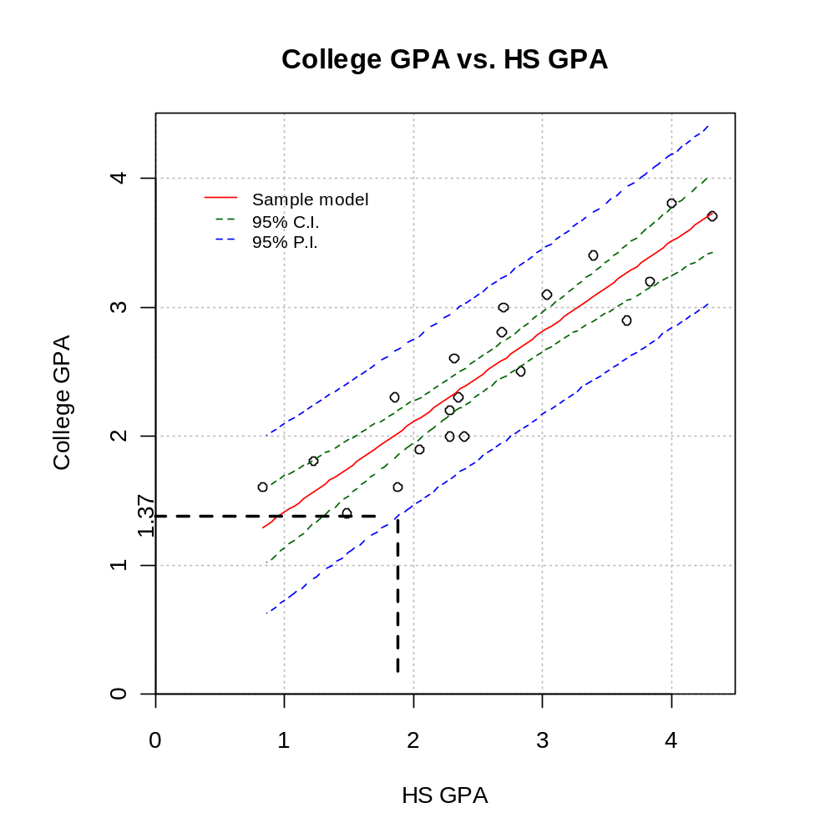

Note: Section 2.6 of KNN discusses another way to construct a C.I. band. The confidence level is (1-α)100% for the entire band. For the C.I. band above, the confidence level is (1-α)100% for each X_{h}.

